**DBMS PROJECT**

**ONLINE INVENTORY MANAGEMENT SYSTEM**

**Key Milestone 2**



## CSE403L Database Management System Lab

Group members

**Arsalan khan (22PWCSE2110)**

**Waseem (22PWCSE2179)**

**Adnan Zeb (22PWCSE2191)**

Class Section: **A**

“On my honor, as student of University of Engineering and Technology, I have neither given nor received unauthorized assistance on this academic work.”

Student Signature:

Submitted to:

## Engr.Sumayyea Salahuddin

(MAY 27, 2025)

Department of Computer Systems Engineering

University of Engineering and Technology, Peshawar

## Conversion of Conceptual Schema into Relational Schema

The conceptual schema of the Online Inventory Management Systemincludes several entities, their attributes, and relationships as defined in the entity-relationship diagram (ERD). These have been translated into a relational schema that adheres to the relational database design principles.

**Relational Schema**

1. **Product** (ProductID [PK], Name, Description, Price, ReorderLevel, CurrentStock, Category)

* **Strong entity**: uniquely identified by ProductID

1. **Supplier** (SupplierID [PK], Name, ContactName, Phone, Email, Address)

* **Strong entity**: uniquely identified by SupplierID

1. **ProductSupplier** (ProductID [PK, FK], SupplierID [PK, FK])

* **Associative entity**: manages the many-to-many relationship between Product and Supplier

1. **Purchase** (PurchaseID [PK], SupplierID [FK], PurchaseDate, TotalAmount)

* **Strong entity**: uniquely identified by PurchaseID

1. **PurchaseItem** (PurchaseItemID [PK], PurchaseID [FK], ProductID [FK], Quantity, UnitPrice)

* **Weak entity**: depends on both PurchaseID and ProductID, but uniquely identified here by PurchaseItemID

1. **Distribution** (DistributionID [PK], DistributionDate, CustomerName, Contact, Address)

* **Strong entity**: uniquely identified by DistributionID

1. **DistributionDetail** (DistributionDetailID [PK], DistributionID [FK], ProductID [FK], Quantity)

* **Weak entity**: depends on both DistributionID and ProductID, identified by DistributionDetailID

1. **StockMovement** (MovementID [PK], ProductID [FK], MovementType, Quantity, MovementDate)

* **Strong entity**: uniquely identified by MovementID

Each entity is designed to capture necessary information while maintaining referential integrity and supporting the business rules described in the conceptual schema.

## Normalization of Relational Schema to Third Normal Form (3NF)

Normalization is a step-by-step process that organizes data to reduce redundancy and improve data integrity. Each relation is normalized from the unnormalized state to 3NF as follows:

**First Normal Form (1NF)**

All relations have atomic values and no repeating groups. Each attribute contains indivisible data.

**Status**: All relations satisfy 1NF.

**Second Normal Form (2NF)**

Relations in 1NF must also have all non-key attributes fully functionally dependent on the entire primary key. For tables with single-attribute primary keys, this is automatically satisfied. For tables with composite keys (e.g., ProductSupplier), all attributes are fully dependent on the full key.

**Status**: All relations satisfy 2NF.

**Third Normal Form (3NF)**

A relation is in 3NF if it is in 2NF and has no transitive dependencies. That means all non-key attributes must depend only on the primary key and not on other non-key attributes.

**Status**: All relations satisfy 3NF, as no transitive dependencies exist.

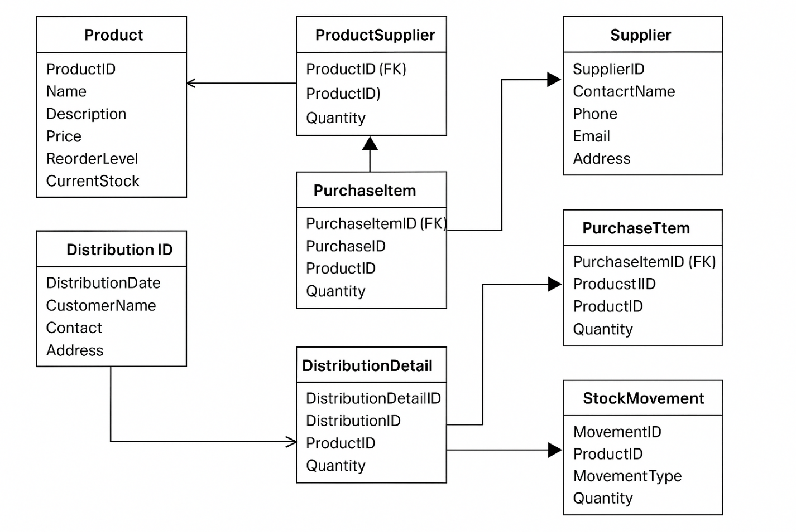

Refrence: https://chatgpt.com/c/6835c66e-c84c-800a-b82e-64696b01e37a